**Homework 8**

1. USTrak is a passenger rail service. The production function for USTrak is given by the following: where L represents man-hours, K represents machine hours and output Q is measured in hundreds of passenger miles (so Q = 1 represents 100 passenger miles). The price of an hour of labor is $25 and the price of an hour of machine time is $1. Assume that that the fixed costs of USTrak are 90,000.

1. Given the input prices and the production function set up the cost minimization problem. Solve the cost minimization problem to determine the (compensated) factor demands for labor and machines. Find the variable cost curve.Given the fixed costs what are the average costs of USTrak? What is the marginal cost curve of USTrak. Illustrate these two cost curves.

*The firm wants to minimize its cost at given output level. So we have to get the factor*

*demand functions first.*

*The cost minimization problem is*

**

*At the cost minimization point, , so*

* *

*Plug this back into the production function, then . Therefore*

*, . These are the compensated factor demands for labor and machines.*

*The variable cost function is .*

*The total cost function is .*

*The average cost function is .*

*The marginal cost function is *

*Q*

*AC*

*MC*

*P*

*AC*

*MC*

10

1. ***Bonus:*** Solve the cost minimization problem using the Lagrange method. Compare the Lagrange multiplier λ with the marginal cost of the firm. Show that this relationship is true for all w and r (ie solve the problem again with parameter values for w and r instead of the specific prices).

Min wL + rK

s.to 

FOC :

















1. For what values of Q do USTrak’s cost curves exhibit “scale” economies?

*The average costs always fall as output as output rises. As long as Q > 0, USTrak shows scale economies. For the technology like this (AC decreases as Q increases), this industry is said to be a natural monopoly.*

1. Demand for passenger rail service is given by Q = 10,000 – 100P where Q is again measured in hundreds of passenger miles and P is the price of 100 passenger miles. Given the cost structure of USTrak what would be the total surplus maximizing quantity traded in this market? At what price would consumers be willing to purchase the surplus maximizing quantity?

*The inverse demand function is P = 100 – 0.01Q. Therefore the total profit is given by*

**

*Q = 4,500 solves the above problem.*

*P = $55 is the price which consumers are willing to pay for this quantity.*

1. At the price and quantity pair that you determined in part (c) what would be the profits of USTrak? Will it be able to stay in business and supply the surlpus maximizing level of rail service? Illustrate your answer in your diagram for part (a).

*.*

*Since the USTrak is making super normal profit, it has the incentive to stay in the business.*

2. Bob’s Basil Farm uses both premium organic manure (x) and compost (y) to fertilize the basil plants. The production function of Bob’s is given by  where both manure (x) and compost are measured in cubic yards and Q is measured in pounds of basil. The price of manure is $64 per cubic yard and the price of compost is $1 per cubic yard. Bob’s has no overhead (fixed costs).

For parts (a) – (b) below assume that Bob’s stock of compost is fixed in the short run. In particular Bob has only 8 cubic yards of compost. This results in fixed costs of $8.

a) In the short run what is Bob’s (compensated) demand curve for manure? What is his variable cost curve? What is his total cost curve?

With y fixed to 8, the production function becomes:



We can solve this to get x:



The costs are:



b) In the short run what is the marginal cost curve of Bob’s Basil Farm? What is the average cost curve? What is the optimal size of the firm? Illustrate the short run marginal and average cost curves below.





3.17

Short-run AC curve

Short-run MC curve

Q

For parts (c)- (d) below assume that Bob’s stock of compost is variable in the long run.

c) In the long run what is Bob’s (compensated) demand curve for manure? What is the (compensated) demand for compost? What is the variable cost curve? What is the total cost curve?

Bob needs to solve the following program:



The first order conditions are:

 (1)

 (2)

Substitute. (1) into (2) to get:



Now, substitute this result back to (1) to get 

To summarize:



The costs are:



d) In the long run what is Bob’s marginal cost curve? What is the average cost curve?



Finally let’s compare the average cost curves in the short and long runs.

e) At what quantity is the demand for compost equal to 8? What must be true about the short and long run average costs at this quantity? Illustrate the long run average cost curve in your diagram for part (b).

Let’s start by first making sure we understand what the average cost (AC) curve is telling us. The AC curve is showing for each quantity Q, the cheapest average cost you can achieve while making sure you produce Q units of output. There may be other ways to produce Q units, but the y-coordinate of the AC curve corresponds to the average cost of the cheapest way.

Now, think about the short-run vs. the long-run for a minute. In the short-run, one of the inputs is fixed (i.e. one of my hands is tied) whereas in the long-run I am free to choose both inputs as I desire to make the cost as cheap as possible. One would thus expect the short-run AC curve to lie above the long-run AC curve (maybe touch it in a few points, but never go below) because whatever cost I can achieve with one input fixed (short-run), I will surely do no worse by being allowed to use both of my inputs to optimize the cost (long-run).

Let’s go back to the question. In the long-run, the demand for input y (compost) is 8 if I need to produce 4 units of output (). In other words, where I can choose both of my inputs freely, if I need to produce 4 units of output, y must be set to 8. In the short-run, y is fixed to 8, so if I want to produce 4 units of output as cheaply as possible in the short-run, I can actually get the same cost as in the long-run (because y happened to be fixed to the optimal long-run value for Q=4 anyways).

For other values of Q, however, the optimal y will not be 8, and so whatever average cost I can achieve in the short-run, will be higher (more expensive) than what I can achieve in the long-run. The two curves are thus tangent at Q=4:

4

Short-run AC curve

Long-run AC curve

Q

3. Suppose that the inverse market demand for bicycle helmets is P(Q) = 130 – 2Q**.** Price (P) is measured in dollars per helmet and quantity (Q) is measured in helmets per day. The total cost curve of a typical helmet manufacturer is C(Q) = 4Q2 + 10Q + 100.

1. What is the average cost curve for a typical helmet manufacturer? What is the marginal cost curve? What is the optimal size of the firm (in number of helmets)? Illustrate the relationship between the average and marginal cost curves.

AC = 4Q+10+100/Q

MC = 8Q+10

4Q+10+100/Q = 8Q+10 => Qopt = 5

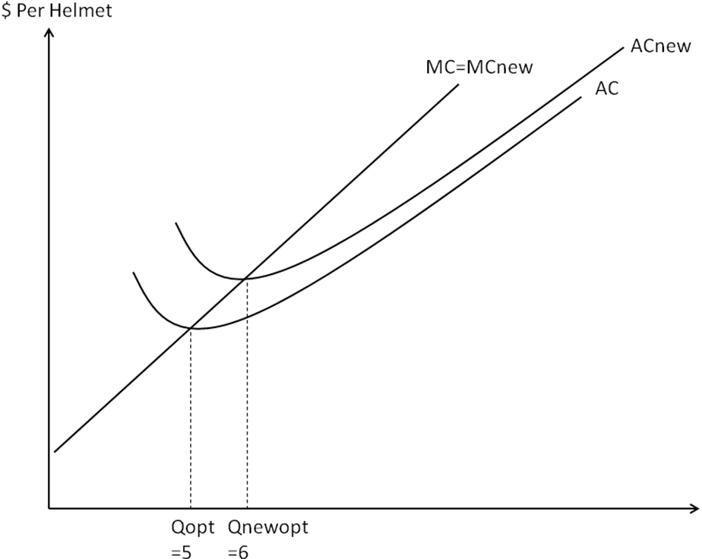

1. If the industry in long-run competitive equilibrium then what is the price and quantity traded in this market? How many manufacturers are in this market?

PLR = 50

Quantity traded = (130 – 50)/2 = 40

# of manufacturers in this market = 40/5 = 8

Suppose that the government charges each helmet manufacturer a licensing fee of $44 per day to sell helmets. The license is a fixed fee so it does not vary with the number of helmets sold.

1. What is the new marginal cost curve for a typical manufacturer? What is the new average cost curve? What is the optimal size of the firm (in number of helmets)? Illustrate the new cost curves in your diagram for part (a).

ACnew = 4Q+10+144/Q

MCnew = 8Q+10

4Q+10+144/Q = 8Q+10 => Qnewopt = 6

1. What is the new long-run equilibrium price and quantity traded in this market. How many firms will there be in the market?

PLR = 58

Quantity traded = (130 – 58)/2 = 36

# of manufacturers in this market = 6

4. The variable cost curve of a typical photo developer is given by VC(Q) = .25Q2 where Q is measured in rolls of film per day. The fixed costs of the developer are $100 per day.

1. What are the total costs of the developer? What are the marginal costs of the developer? What are the average costs? What is the optimal scale of the firm?

Total cost



average cost



marginal cost



Qopt=20

1. Illustrate the marginal and average cost curves. Be sure to indicate the optimal scale of the firm and the minimum average cost of the firm.

optimal scale of firm Q=20

Minimun average cost 10

Suppose that there are currently 10 developers in the industry and each firm is producing 30 rolls per day. Assume that the firms are all perfectly competitive.

1. If each firm is producing 30 rolls then what must be the price in the market? When each firm is producing 30 rolls are the firms earning normal, supernormal or subnormal profits? Illustrate the profits of the typical developer when it is producing 30 rolls in your diagram for part (b).

Since inverse of marginal cost function is supply function the price must be 15

Since the price is greater than the average cost of the firm, firms will earn supernormal profits

Profit(Q)=R(30)-C(30)=$125>0

1. Do you predict that there will be entry or exit from this market? What will be the long run price for developing a roll of film?

Since the firms are earning supernormal profits firms will enter the market

long run price will 10

1. Suppose that the variable costs of developing film rise by 21%. Will marginal cost rise by 21%? Will average cost rise by 21%? Will the optimal size of the firm increase or decrease? By how much will the price rise in the long run?

The marginal cost will rise by 21% and the average cost will rise less than 21%(since only variable cost has been increased ). The optimal size of the firm will decrease by . The price will increase by



5. There are three firms in the printing business. Firm 1 has a total cost curve given by  where Q is measured in books printed per day. Firms 2 and 3 have identical costs to each other but their costs are higher than firm 1. In particular, the total cost curve is(j=2 or 3). The daily demand for books is given by QD=550-15P.

1. What are the marginal costs of firm 1? What are the average costs? What is the optimal scale of firm 1? What is the supply curve? Illustrate firm 1's marginal and average cost curves. What are the marginal and average costs of firm 2? What is the optimal scale of firm 2? What is the supply curve? Illustrate firm 2's marginal and average cost curves in a separate diagram.

MC1 = 0.2Q1

AC1 = 0.1Q1+250/Q1

MC1 = AC1 => Q1opt = 50

MC2 = 0.2Q2 + 5

AC2 = 0.1Q2 + 5 + 250/Q2

MC2 = AC2 => Q2opt = 50

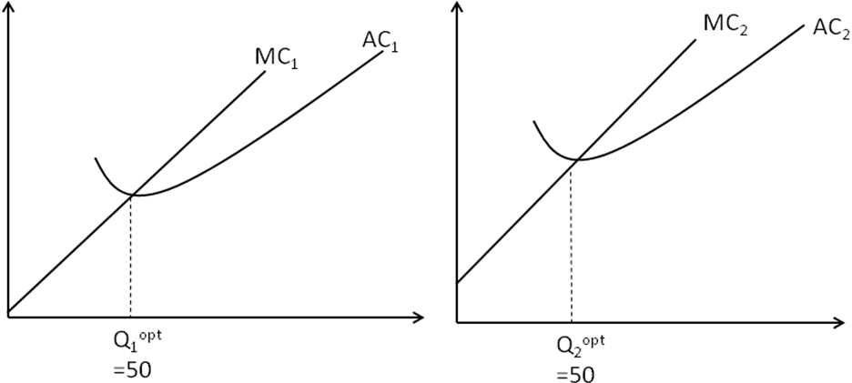

1. What is the market supply of the 3 firms? What is the market clearing price and quantity in the short run?Are firms earning positive profits in the short run? (Yes,No and why - do not calculate the numbers).

Q1s (P)= 5P if P≥10

0 otherwise

Q2s (P) = Q3s (P)= 5P-25 if P≥15

0 otherwise

Market supply

QS = 5P + 2*(5P-25) if P≥15

= 5P if 10≤P<15

= 0 otherwise

QS = QD => Market Clearing Price = 20

Quantity traded = 550 – 15*20 = 250

Firm 1 supplies 100, and Firm 2 and 3 supplies 75 each.

Yes. Firms are earning because the market clearing price is greater than AC.

Suppose that firms can freely copy the technology of firms 2 and 3 but not firm 1. So if a firm enters the market the firm will have the same cost curve as firms 2 and 3.

1. In the long run, if firms can enter and exit the printing business then what will be the long run market clearing price and quantity traded? What will be the profits of the 3 firms in the long run? Illustrate the long run profits in your diagrams for parts (a) and (b).

PLR = 15

Firm 1 supplies 75, and all the other firms supply 50 at P=15.

Long run Quantity traded = 550 – 15*15 = 325

325 = 75 + N*50 => N = 5

Firm 1’s profit = 75*(P- AC1(75) )=75*(15- 0.1*75 -250/75) = 312.5

All the other firms’ profit = 0

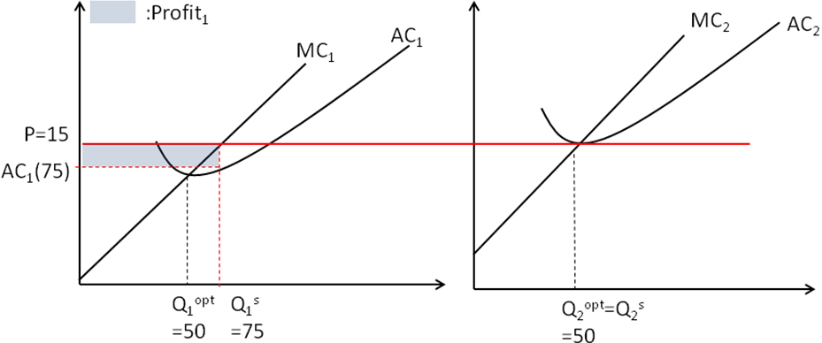

6. Suppose that daily demand in Stockton for shoe repairs is QD(P) =425 –10P**.** Price (P) is measured in $ per pair and quantity (Q) is measured in pairs per day. Suppose that the total cost curve for a typical cobbler is C(Q) = . 1Q2 + 5Q + 10**.**

1. What is the average cost curve for a typical cobbler? What is the marginal cost curve? What is the optimal scale of the cobbler? Illustrate the relationship between the average and marginal cost curves.

AC = 0.1Q + 5 + 10/Q

MC = 0.2Q + 5

Qopt = 10

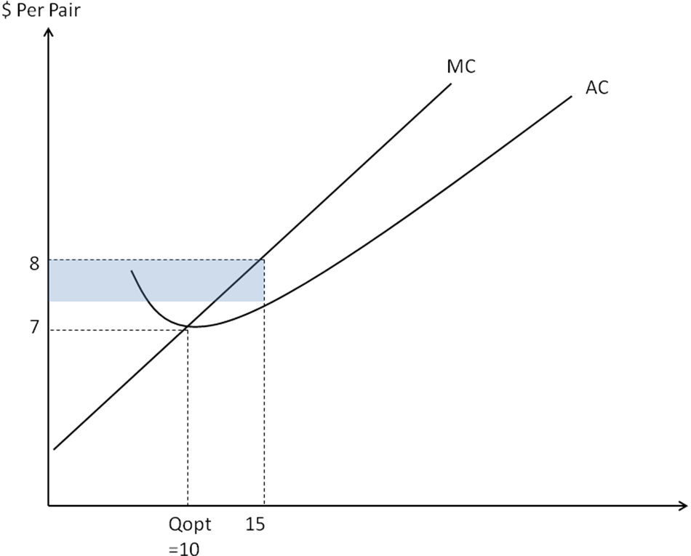

1. What is the supply curve of a typical cobbler? If there are 23 firms in the industry each of which has the typical cost curve then what is the industry supply curve of shoe repair services?

Qj (P) = 5P-25 if P ≥ 7

0 otherwise

Market supply : QS = 23*(5P-25) = 115P - 575 if P ≥ 7 , 0 otherwise

1. If the market is perfectly competitive then what will be the market clearing price per pair and the number of pairs repaired in the short run? Illustrate your answer in a supply and demand curve diagram.

QD = QS => P* = 8 ; Q*=345 ;

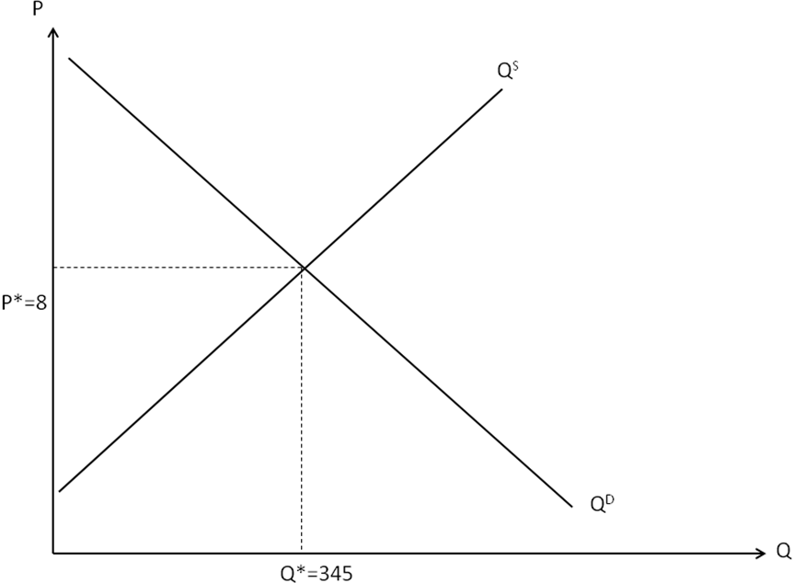

1. How many pairs will each firm repair? What is the elasticity of the demand curve that an individual firm faces? Illustrate your answer in a diagram of individual firm supply curve and individual inverse firm demand curve. Illustrate the producer surplus of the individual firm.

Each of 23 firms supplies 345/23=Qj(8)=15.

In a perfectly competitive market, the individual firm demand is always perfectly elastic at the market price.

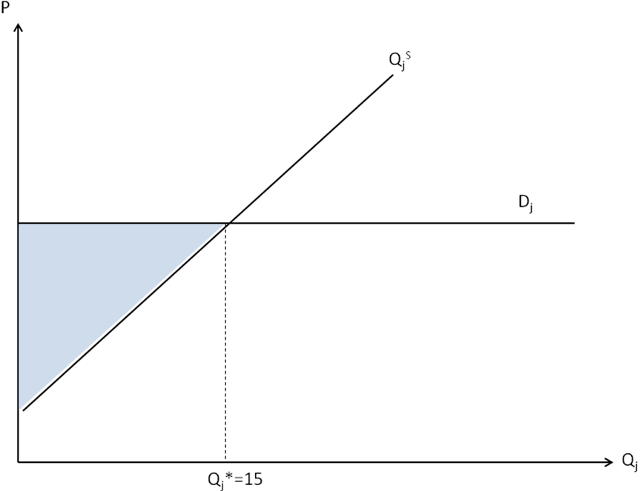

Dj is the individual firm demand.

PS of the individual firm: Blue triangle

1. In your diagram for part (a) illustrate the daily profits of the typical cobbler.

Profit of the typical cobbler : blue rectangle

7. Consider a market composed of 8 buyers and 8 sellers. Each of the 8 sellers has one unit of the good to sell and each of the buyers wants to buy exactly one unit of the good. The reservation prices of the buyers and the costs of production of each of the suppliers are given in the following table;

|  |  |  |  |
| --- | --- | --- | --- |
| **Buyer** | **Reservation Price** | **Seller** | **Cost of 1 Unit** |
| Alice | 10 | Alex | 2 |
| Blanche | 9 | Bob | 3 |
| Cary | 8 | Charles | 4 |
| Donna | 7 | David | 5 |
| Edwina | 6 | Edgar | 6 |
| Fanny | 5 | Fred | 7 |
| Georgia | 4 | Glenn | 8 |
| Harriet | 3 | Howard | 9 |

1. Assume that both buyers and sellers are perfectly competitive. What is the market clearing price? What is the total surplus associated with the market clearing price and quantity?
2. Match each buyer with a seller such that each can gain by trading with the other (for example a buyer with a reservation value of 4 can be matched with a seller with a cost of 3 and each could gain by trading with the other). What would be the total surplus generated by this matching of every buyer and seller? Compare your answer with (a).
3. Although the surplus is higher in (a) than in (b) are there some traders that would prefer the outcome in (b)?
4. ***Bonus:*** show that there is no matching mechanism that generates more surplus than the surplus generated by the competitive equilibrium.

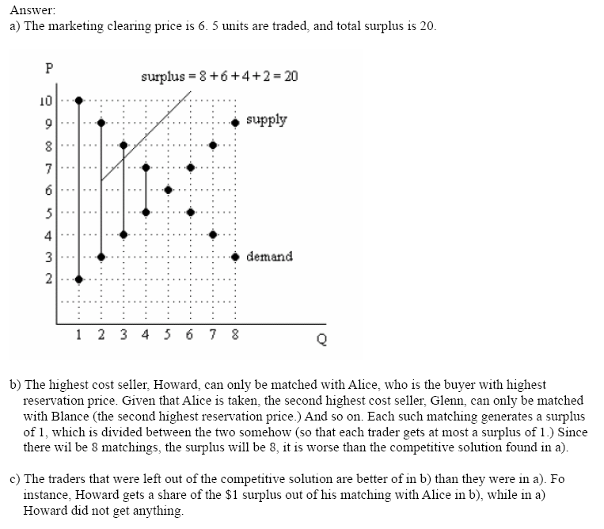

8. Suppose that the daily market demand curve for cheese in Parksdale is QD(P) = 1600 - 50P**.**  Price (P) is measured in dollars per pound and quantity (Q) is measured in pounds per day. The total cost curve of a typical cheese supplier is C(Q) = .02Q2 + 2Q + 128**.**

1. What is the average cost curve for a typical supplier? What is the marginal cost curve?

AC = .02Q+2+128/Q

MC = .04Q+2

1. What is the optimal scale of the supplier? Illustrate the AC and the MC in a diagram and indicate the optimal scale.

.02Q+2+128/Q = .04Q+2 => 128=.02Q^2 => Q_opt = 80

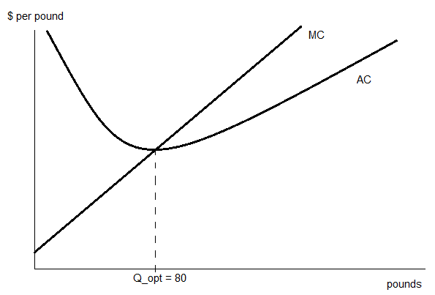

1. What is the short run supply curve of the typical supplier? If there are 10 firms in the industry then what is the short run market supply curve?

P = MC(Q)

P = .04Qi + 2

QSi = (P-2)/.04 = 25(P-2)

QS = 10*25(P-2) = 250(P-2)

1. What is the short run market clearing price of cheese? What will be the quantity traded at this price?

Q = 250(P-2) = 1600 – 50P => 300P = 2100 => P = 7

Q = 1600 – 50(7) = 1600-350 = 1250

1. Illustrate the supply and demand curves in a diagram .

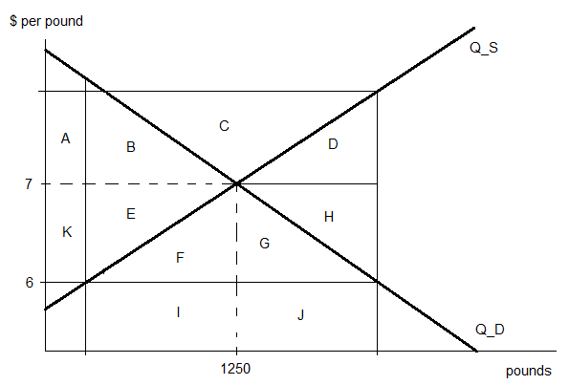

Suppose the government of Parksdale decides to lower the price by $1 by selling some of its reserves of cheese.

1. Illustrate in your diagram from part (d) the impact of the government’s sales on the consumer and producer surplus in the cheese market. Indicate the government’s revenues from the sales.

Impact on consumer surplus = +K+E+F+G

Impact on producer surplus = -K-E

Government revenue = I+J

1. If the government valued its reserves of cheese at the original market clearing price (part c) then illustrate the cost to the government of the sales of cheese at the lower price in your diagram. Indicate one source of deadweight loss that arises from the sale.

Cost to the government = E+F+G+H

DWL = E+H